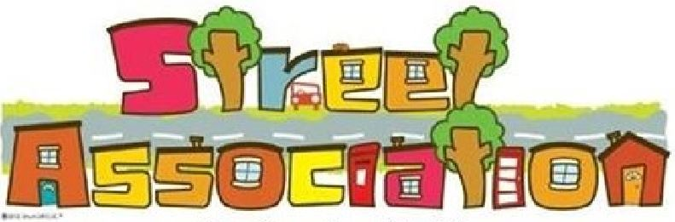

Street Associations bring together local residents who want to make their community stronger, friendlier and more supportive, where people belong and look out for one-another.
The community scheme provides all the resources you need to offer that little bit of advice to your neighbours and to point them in the direction of relevant services if needed.
Pilot schemes have been set up in Hughenden, Aylesbury’s Quarrendon, Chesham and Burnham with a launch planned for Princes Risborough in 2018. Feedback from residents show they feel safer and better connected in their streets with some organising litter picks, checking on neighbours in bad weather, sharing information to protect from scams or meeting socially.
To find out more, please contact:
Helen Cavill - Project Lead
Street Associations
Buckinghamshire County Council
07712 439146
helencavillsa@hotmail.com
Street Association Bucks Webpage

